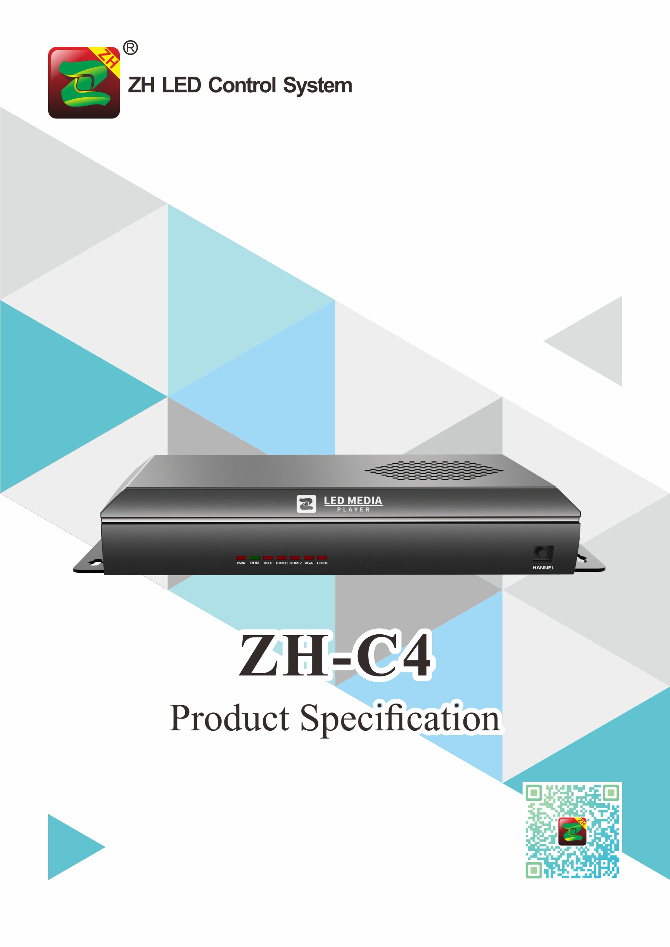

Product Specification
ZH-C4
I. Function Introduction:
ZH-C4 belongs to full color series LED player, its functions are as follows:
- Adopt the same refresh technology as synchronous control system;
- Support cascading receiving cards, support any size screen;
- Support mobile APP (Android + iPhone) to send program;
- Support U-disk, Wi-Fi hot-spot (AP mode) and Internet (STA mode) to realize cluster management;
- Support remote cluster release management system;
- Offer SDK file;
- Support HD video hard decoding;
- Supports audio output, 3.5mm standard audio output interface;
- Support USB to play video and pictures directly;
- Support brightness automatic, timing adjustment;
- Support program play in sequence and timing;
- Support UDP network communication protocol;
- Support DHCP to obtain IP address automatically;
- Support emergency information insertion;
- Support weather forecast;
- Support 1 pcs HDMI output port;
- Support one-button full screen test;
- Support 2pcs video Windows to play simultaneously;
- Support manual switch, timing switch;
- Support log, screen status checking;
- Support multi-device play synchronously;
- Support cloud login dynamic verification, support grouping, classification, monitoring, verify and other permission to manage.

II. Basic Function Parameters
System Parameters
CPU | 8-core A53, 1.5GHz
Operation System | Android 5.1
System Storage | 8G (The system takes up about 2.5G)
Control Area | Loading Points: 2.0 million points  Maximum Width: 4096，Maximum Height: 2160
Support Resolution  (Width*Height) | 960*2160 1012*2048 1080*1920 1152*1792 1296*1600 1480*1400 1518*1366 1620*1280 1800*1152 1920*1080 2048*1012 2304*900 2560*810 2592*800 2816*736 3072*672 3200*648 3264*632 3456*600 3600*576 3672*564 3840*540 4096*512
Receiving card | All series ZH receiving card
Device Port
Synchronous input interface and quantity | Not support synchronous
Asynchronous input interface and quantity | Gigabit network*1,USB*2,WiFi*1
Output port and quantity | Gigabit network*4, Audio*1, HDMI*1
Media playback formats
program, window | Multi-program sequence, timing and other playback methods; arbitrary partition and overlay playback of windows
Video formats | AVI,F4V,WMV,MPG, RM/RMVB,MOV,VOB,MP4,FLV,TS,MKV and other common video formats; can support 2 video windows to play at the same time
Picture formats | BMP、JPG、PNG、GIF and so on
Audio formats | MPEG(MP3)、AAC and so on
Text document | Support software to edit single-line, multi-line, colorful text; support TXT documents import; support word, Excel, PPT, etc. of 2007 or later versions of office import
Other function | Support clock, watch face, timing, weather forecast (commercial grade), streaming media, etc.
Management and control
Software | PC：LEDPlayerV5；APP：LED Mobile Color; WEB
Program update communication | U disk export, plug and play; self-adaptive 100M/1000M network port direct connection or access to LAN to send; WiFi AP mode or STA mode control
FPGA file | Built-in many brand module FPGA file, can quickly debug the display
Brightness setting | Screen brightness can be set according to time
Remote controller | Play volume, signal, material, etc. can be controlled through the software remote control function
cluster mode | Support local server cluster, Support cloud server cluster
Safety
Local | Support local send password setting

III. Input/Output Port Arrangement and Definition

Hardware Introduction:

The Front Panel

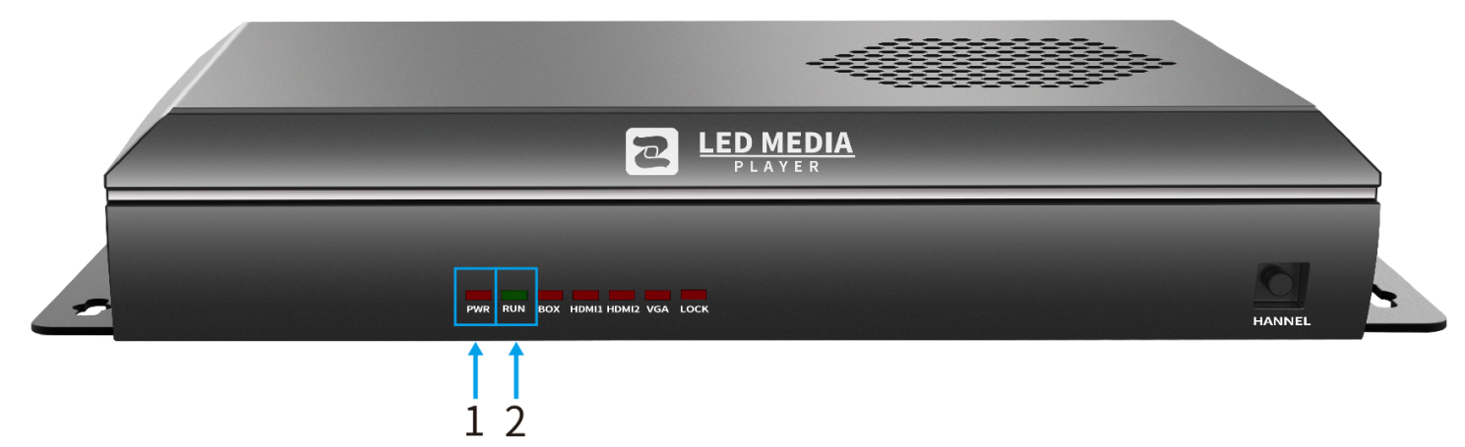

The Back Panel

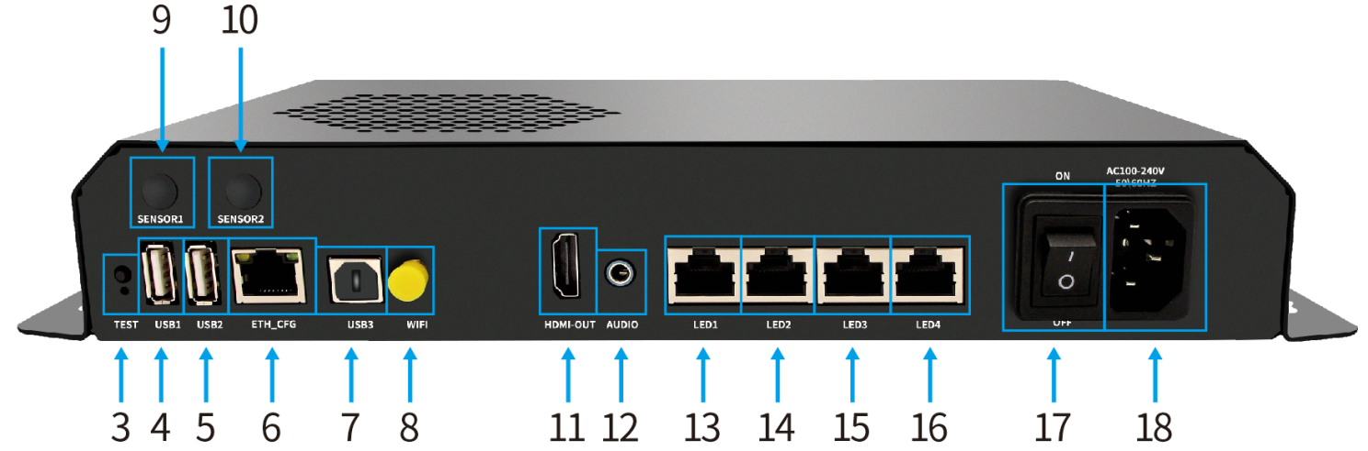

NO.: | Name: | Function: | Note:
1 | Indicator | Power indicator | Red light always on
2 |  | Operation indicator | Green light flashing regularly
3 | Test button | Checking device information, test screen | 13 kinds of test mode
4 | USB port | Read content, enlarge memory
5 | USB port | Read content, enlarge memory
6 | PC port | Link with PC, set parameter, send content
7 | USB port | Hardware update
8 | WiFi antenna port | Link with WiFi antenna
9 | Sensor port | Connect with light sensor | Need to be customized
10 | Reserved port | Reserved interface for backup | Need to be customized
11 | HDMI port | HD HDMI output
12 | Audio output port | Connect external active amplifier
13 | Gigabit port | Link with receiving card
14 | Gigabit port | Link with receiving card
15 | Gigabit port | Link with receiving card
16 | Gigabit port | Link with receiving card
17 | Switcher | Power switcher
18 | 220V port | 220V power input port

Working Condition:

Rated voltage (V) | 220 | Maximum | 240 | Minimum | 100
Rated current (A) | 0.15 | Maximum | 0.3 | Minimum | 0.1
Rated power consumption (W) | 33 | Maximum | 50 | Minimum | 20
Extreme temperature(°C) |  | Maximum | 80 | Minimum | -40
Working environment temperature (°C) |  | Maximum | 80 | Minimum | -40
Working environment humidity (%) |  | Maximum | 95 | Minimum | 0

IV. Hardware Diagram:

